RESOLUTION NO.__________

RE: CERTIFICATE OF APPROPRIATENESS UNDER THE
PROVISIONS OF THE ACT OF THE PENNSYLVANIA
LEGISLATURE 1961, JUNE 13, P.L. 282 (53
SECTION 8004) AND BETHLEHEM ORDINANCE NO.
3952 AS AMENDED.

WHEREAS, it is proposed to install a sign at 128 W Fourth Street.

NOW, THEREFORE, BE IT RESOLVED by the Council of the City of Bethlehem that a Certificate of Appropriateness is hereby granted for the work.

Sponsored by: (s)

(s)

ADOPTED BY COUNCIL THIS DAY OF

(s)
President of Council

ATTEST:

(s)
City Clerk

HISTORIC CONSERVATION COMMISSION

CASE # 583– It is proposed to install a sign at 128 W Fourth Street
OWNER/APPLICANT: Campbell Real Estate Investments LLC/ Jeff Kicska @ And the Sign Says

The Commission upon motion by Mr. Evans seconded by Mr. Trapman adopted the proposal that City Council issue a Certificate of Appropriateness for the proposed work described herein:
- The proposal to install a sign at 128 W Fourth Street was represented by Matt Tranter, Adrea DeJesui and Jeff Kicska.

- A new sign will be pin-mounted to the left panel of the storefront sign band.

- The sign will be slightly reduced in size so that there is approximately 2” of space above and below between the sign and the existing panel moldings. Instead of approximately 36” x 88¼” the sign will be approximately 32” x 78” in size

- The sign will be made of flat acrylic lettering and read “A List Salon”. The A and Salon will be black with scissors and “list” in brushed gold laminate.

- The existing “open” sign may remain, but may not flash.
- The proposed motion was unanimously approved.

CU: cu
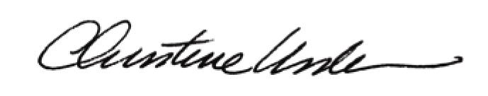

By:

Date of Meeting: March 21, 2016 Title: Historic Officer

